Assignment 3 : Part 1

|  |  |
| --- | --- |
| **Summary** | In this codelab, the data generated after applying adstock model is analyzed |
| **URL** | NA |
| **Category** | Web |
| **Environment** | Salesforce Einstein Analytics, CSV |
| **Status** | Draft |
| **Feedback Link** | NA |
| **Author** | Priyanka Donta, Yadukrishnan Sethumadhavan, Rohit Tikle |

# How to work with csv files

We have converted the week numbers into groups such as for 1-26 we have given GROUP 1 and 27-52 for GROUP 2.We did this by creating buckets by adding new recipes.

We formulated new columns after analyzing our need:

tv_Sales1-base_sales

tv_Sales2-base_sales

tv_Radio_Sales_1-tv_Sales_1

tv_Radio_Sales_2-tv_Sales_2

As weeks had the numeric value, to convert them to dimensional they had to be converted to strings. So we padded the numbers with 00 for eg 1 to 001.

# How is sales related to week numbers?

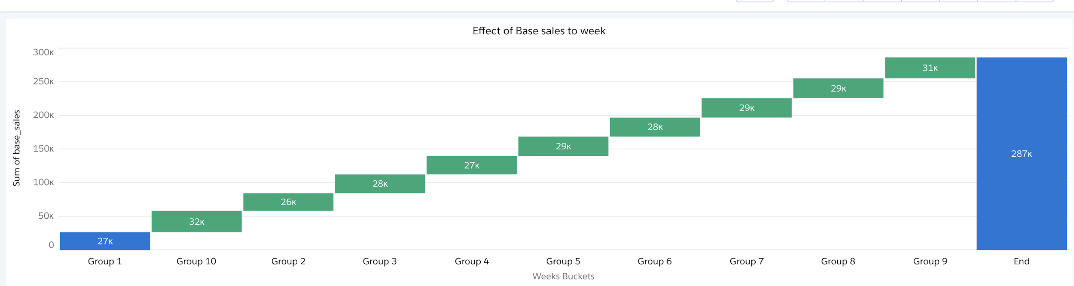

Here we have used a waterfall chart , we have grouped the week numbers into groups from 1-10 and each contains 26 week numbers.

Plotted Base sales vs Week buckets, can say that as we are going forward with weeks the base sales seems to have increased

# How does TV spending affect sales? Can you quantify it?

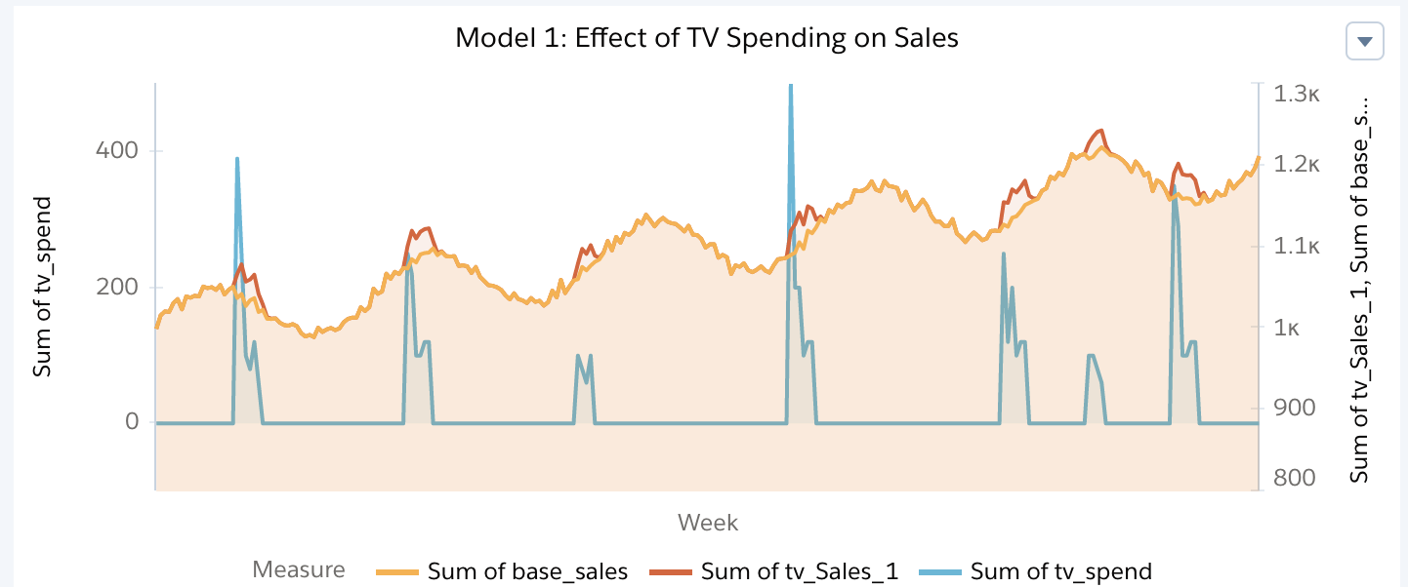

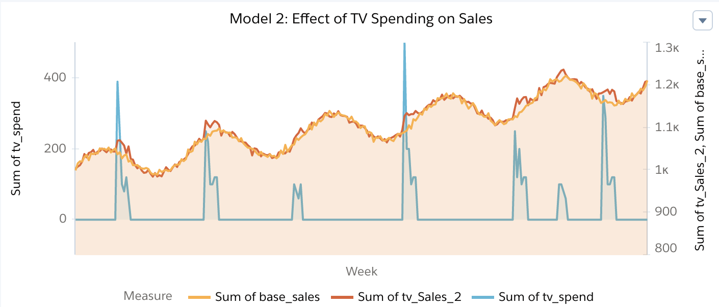

The tv spending has a direct impact on increase in the sales as shown in the graph. Where the Sales have a spike when there is tv spend.

# Are there any adstock effects for Tv ad spending?

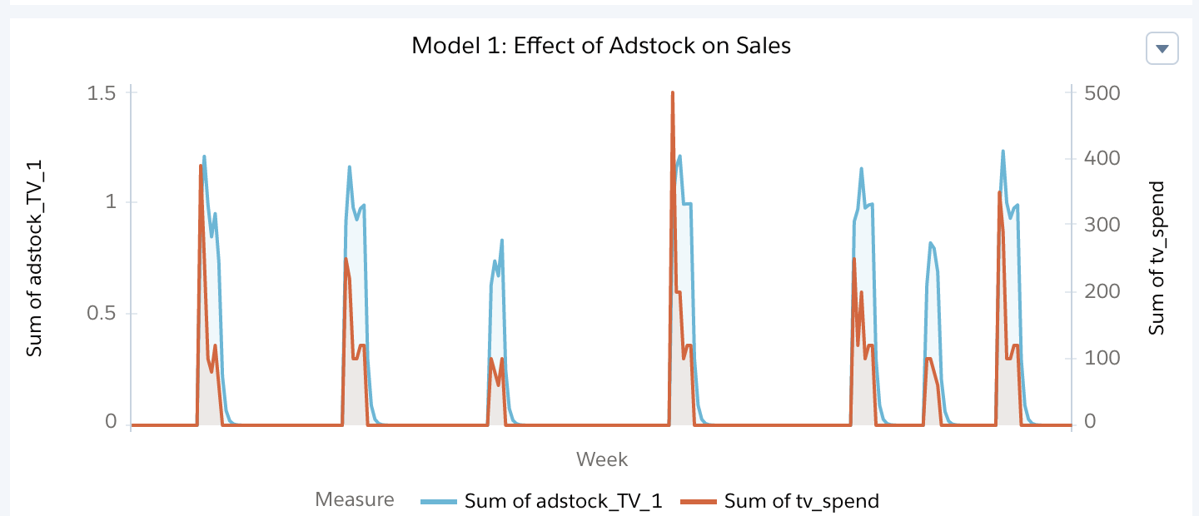

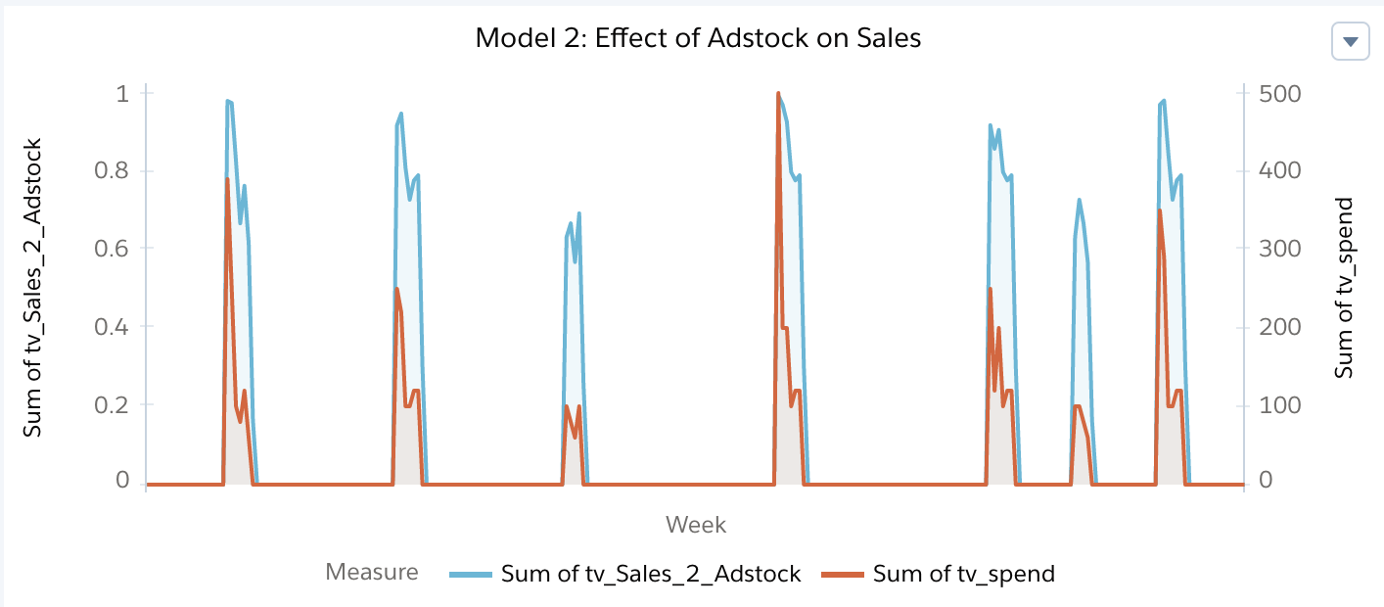

The adstock effect is directly proportional to expenditure.

# How does Radio spending affect sales? Can you quantify it?

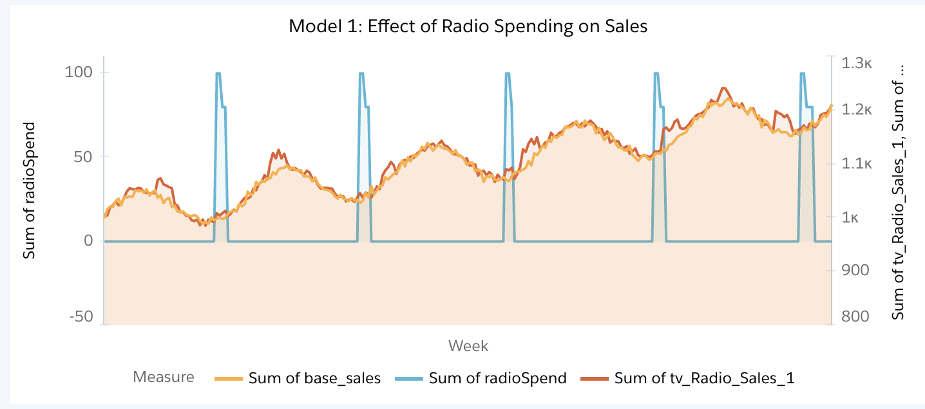

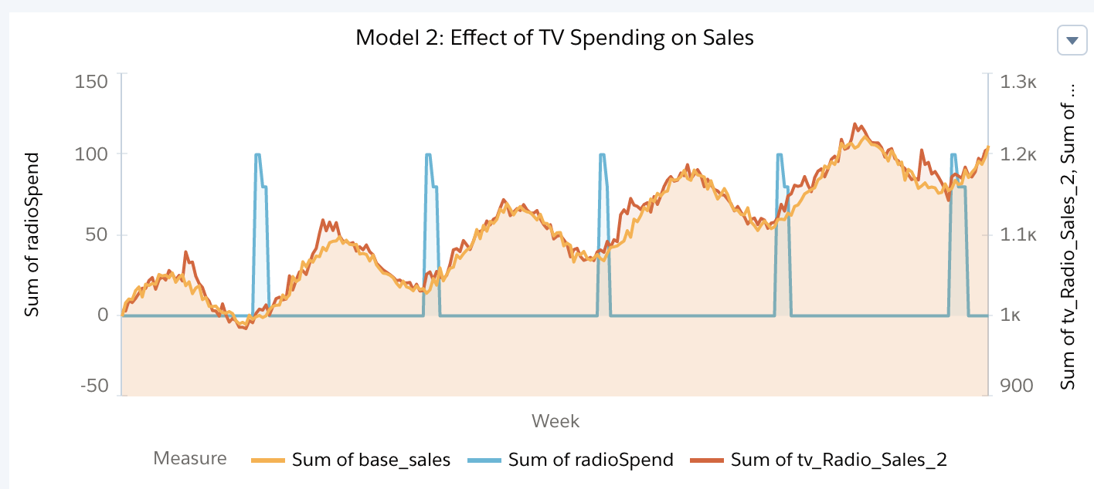

As seen in the graph the sales increased after a few weeks of radio spending. There is no immediate impact on the sales.

# Are there any adstock effects for radio ad spending?

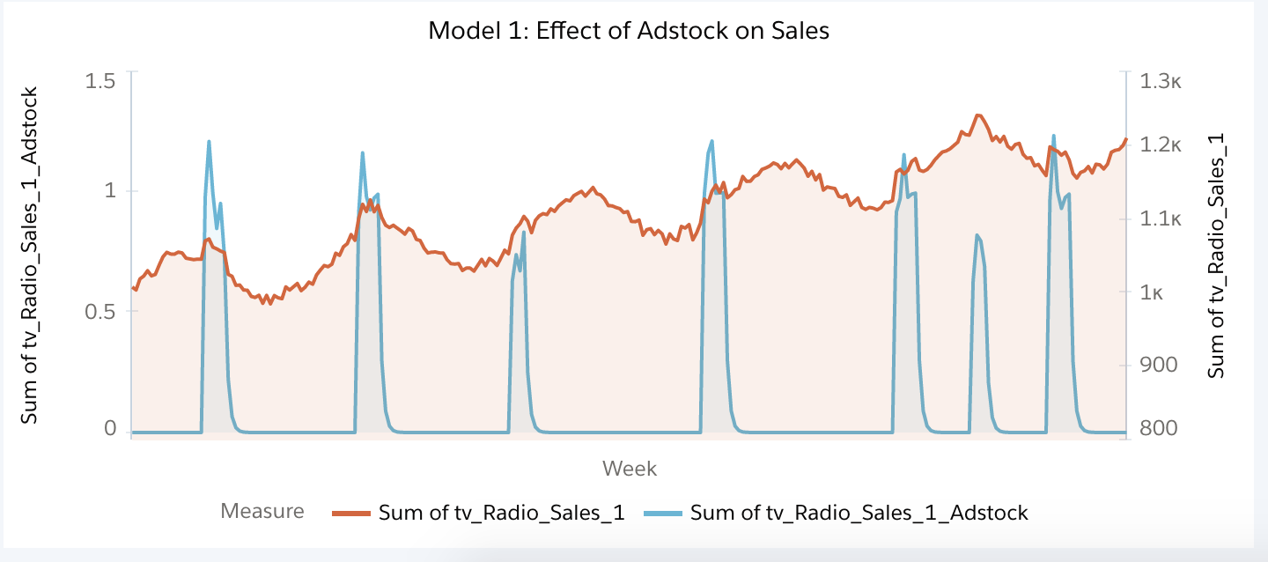

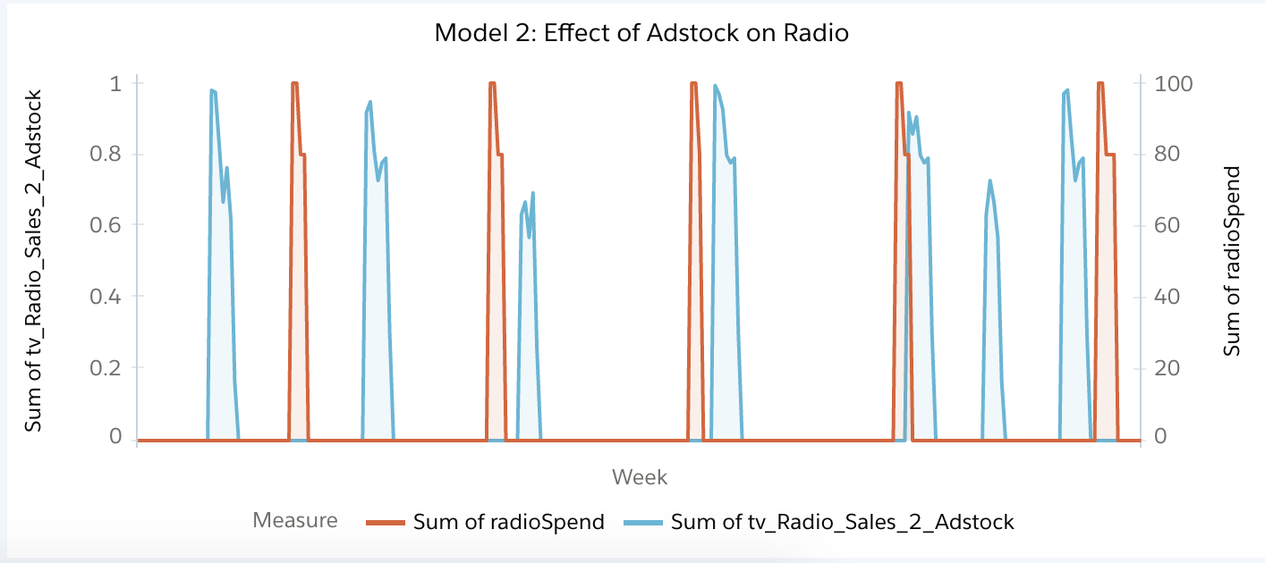

The adstock is created after a few weeks of radio spend as shown above.